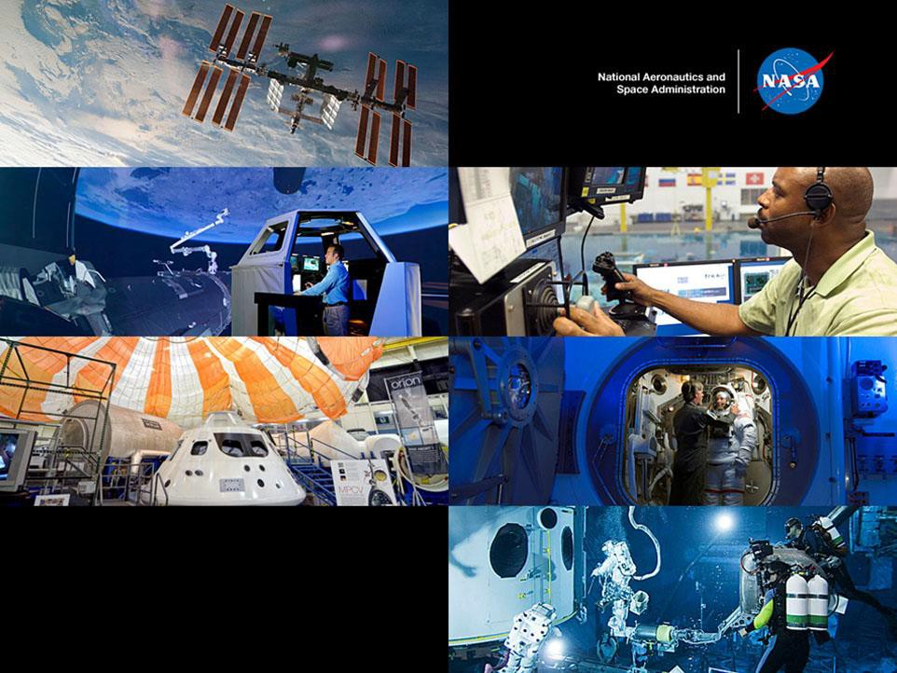


NASA Internships

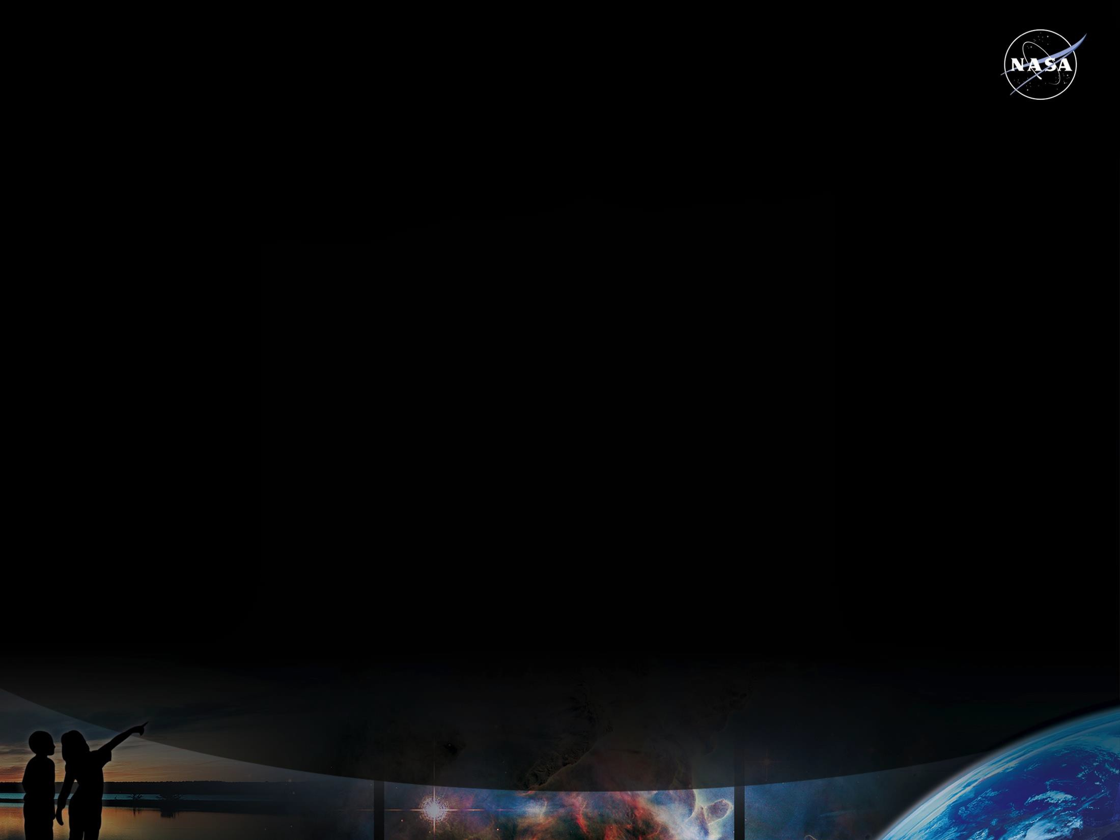
NASA Internships

Overview:
NASA Internships are competitive awards to support educational opportunities that provide unique NASA-related research & operational experiences for educators, high school, undergraduate & graduate students.

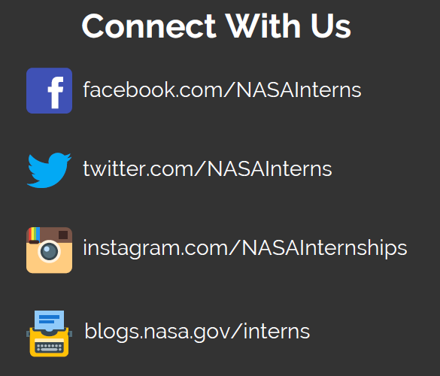
Eligibility Requirements
- US Citizen

- 3.0 GPA on a 4.0 scale

- At least 16 years of age at the time of application

- Enrolled in a degree-seeking program
at an accredited college or university
Sessions
- Spring 2021 (16 weeks)
Application deadline: 11/6/20

- Summer 2021 (10 weeks)
Application deadline: 3/5/21

- Fall 2021 (16 weeks)
Application deadline: 7/9/21

For additional information about NASA’s internship program and to submit an application, go to:
intern.nasa.gov

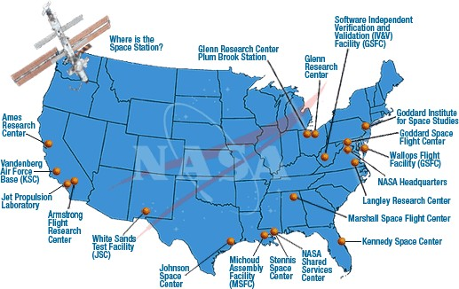
NASA Centers and Field Sites

Armstrong Flight Research Center

What Majors Does NASA Look For?

Primarily we look for STEM Majors (Science, Technology, Engineering, and Mathematics). Additionally, some projects will call for Communications, Public Affairs, Journalism, Education, Graphics, Business and Finance.

Project needs change each session according to the organization’s needs. Some skills that NASA routinely needs are:

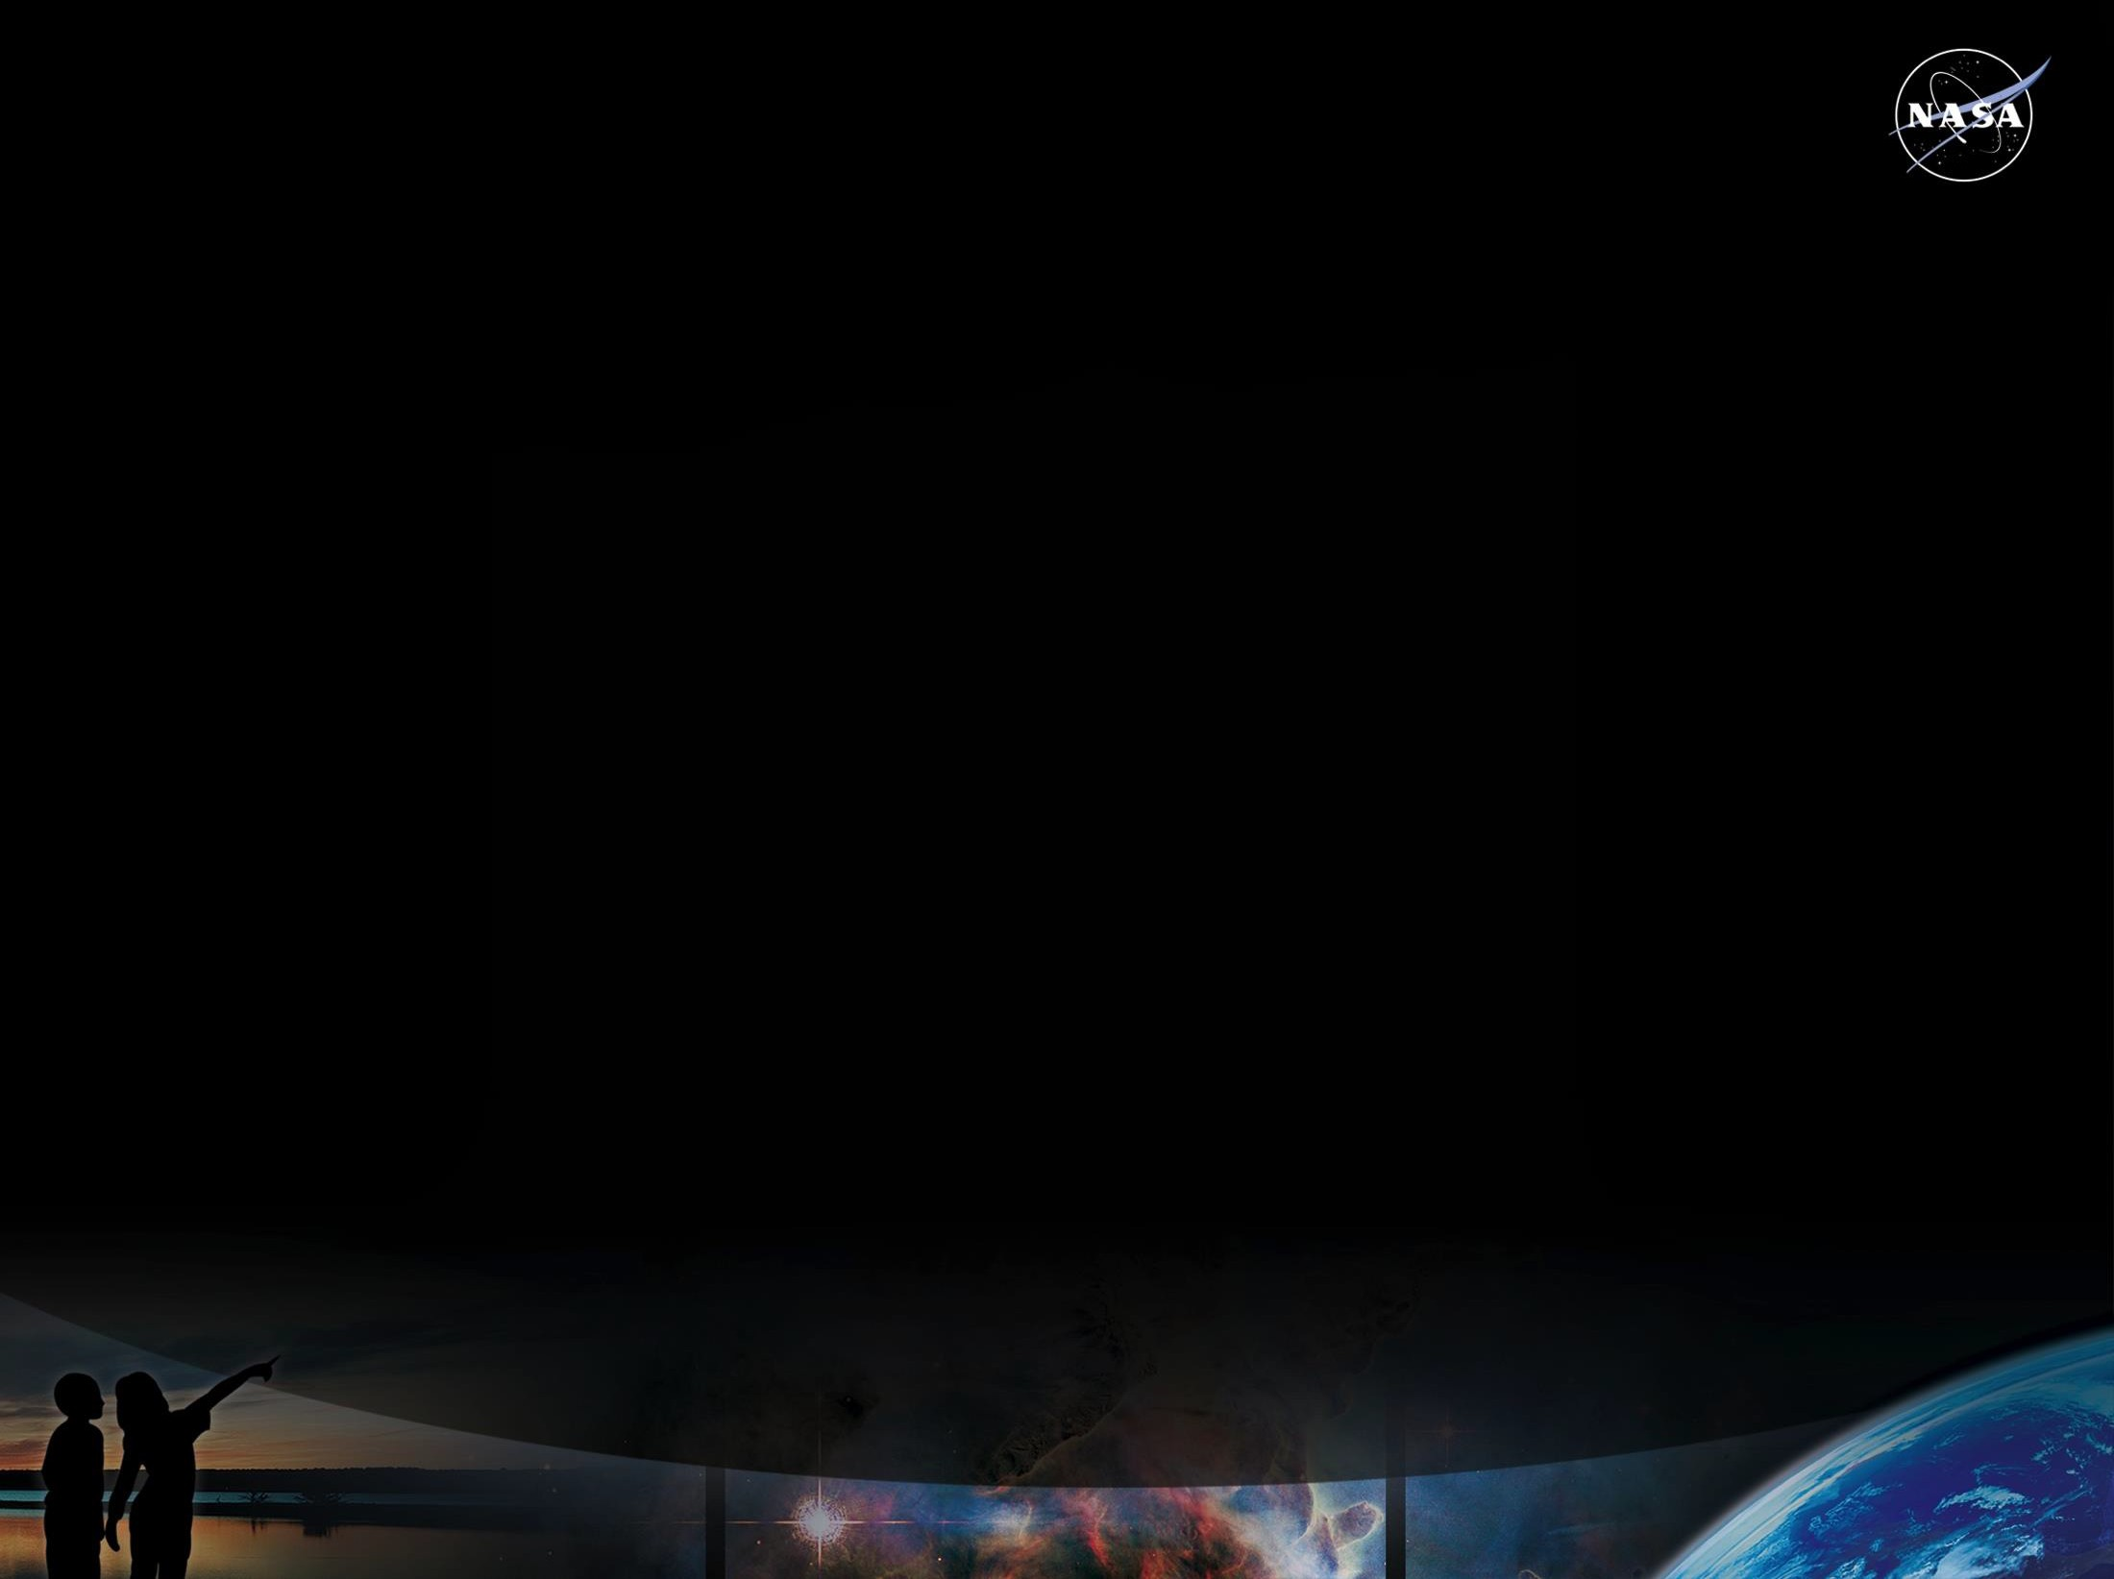

- Programming: C++, JAVA, HTML
- CAD, PRO-E, Matlab, 3D Modeling
- Networking
- Machine Shop, fabricating design, prototyping
- 3D printing
- Social Media
- Technical Writing
- Database Administration

Ready to Apply?
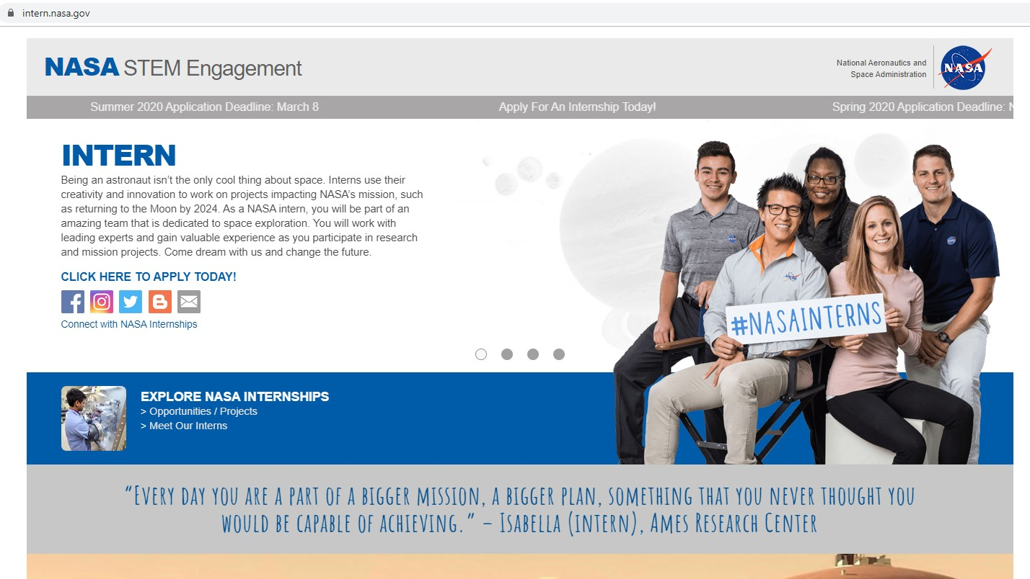
For additional information about NASA’s internship program and to submit an application, go to intern.nasa.gov

Make Your Application Stand Out
Important sections of your application are:

Computer Skills
Describe your knowledge of any computer skills, software languages, hardware, or any specialized computer programs.

Technical Skills
Include any knowledge or capabilities to perform specialized tasks. This may include laboratory experience, special tools machine shop, etc.

Other Skills
List any other skills needed. This includes soft skills (communication, leadership,
teamwork, etc.)

Previous NASA Program Experience
List any NASA program/internship or project experience

Application Keyword Function

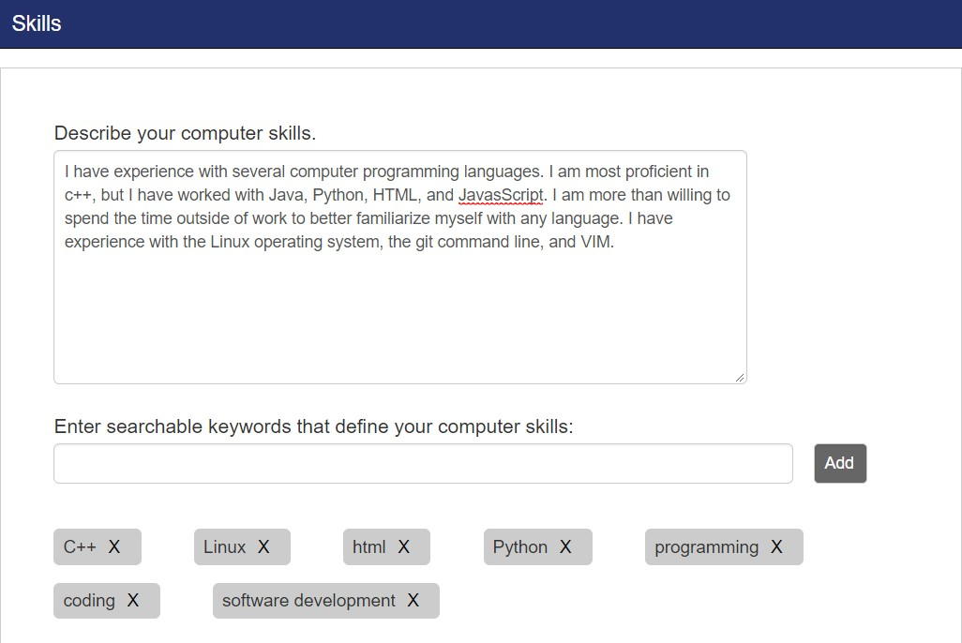

Make Your Application Stand Out

  - Apply to every session that you are available (spring, summer, fall)

  - You can apply to up to 15 opportunities!

  - Spell out any program acronyms:
    - NCAS: NASA Community College Aerospace Scholars
    - HAS: High School Aerospace Scholars


  - Explain in detail your research interests and technical skills.

  - Think “filters”; using key words may boost the chances of your application being viewed by a mentor.

Frequently Asked Questions

Can International Students Apply?
All applicants must be U.S. citizens in order to apply for an internship. More information about opportunities for international students can be found at www.nasa.gov/stem/international-internships-for-students.html.

Will Housing Be Provided if the Internship is In-Person?
Interns are responsible for their own housing arrangements. This includes locating and paying for their housing. Centers may offer minimal assistance by providing a list of local housing options and/or establishing a social media group for interns for utilize for relocation planning purposes.

Are the Internships Paid?
The majority of interns receive a stipend award, but there are some volunteer opportunities noted in the project descriptions at specific NASA centers.

Fall/Spring Internship – 16 Weeks Undergraduates: $11,680 Graduates: $14,400
Summer Internship – 10 Weeks Undergraduates: $7,300 Graduates: $9,000

Frequently Asked Questions

How do I know my application was received?
Once your application has been completed (indicated by green checkmarks), you can go to the section called "Submission Status." Certify your application by clicking the green checkbox and clicking submit. You will then see a message that says "Thank you for your submission!" Please do not call the center to confirm that they have received your application.

How can I check the status of my application?
The system will notify you via email if you receive an offer. You may also log into your application and go to "View My Offers" to view pending offers. Please refrain from emailing the help desk or contacting a NASA center about your application status. You will be contacted if you are considered for a project.

